--- CALL FOR NOMINATIONS FOR THE MINERVA PRIZE of the DPC & NNV ---

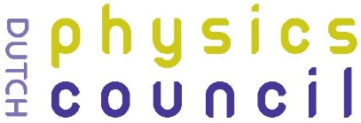
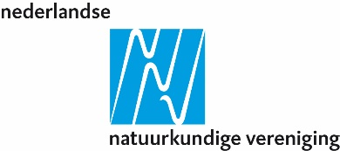

MINERVA PRIZE – The Minerva Prize is an annual award to outstanding young female or non-binary physicists in the Netherlands with an overall performance that scientifically excels in any subfield of physics. Candidates can work in academia, TO2 institutes or at universities of applied sciences.

Aim of the Minerva prize:
The Minerva Prize is awarded annually to an outstanding young female or non-binary physicist in the Netherlands with an overall performance that scientifically excels in any subfield of physics. Both experimental and theoretical scientific physics research carried out at Dutch universities, research institutes (incl. TO2 institutes), university medical centers, or at universities of applied sciences are taken into account. The prize is a tribute, and the laureate serves as an inspiring example for others. The winner receives a sum of € 5,000 that can be spent as wished, together with a prize certificate, and is invited to present their research at a national meeting.
The Minerva Prize is a joint award by the Dutch Physics Council (DPC) and the Netherlands’ Physical Society (NNV) with the aim to support gender diversity in the Dutch physics community.

RULES & INSTRUCTIONS

Who is eligible for the prize?
Nominees for the Minerva prize are female or non-binary physicists. The candidates should have a professional scientific life period up to maximally ten years after finishing a physics or other relevant Master of Science programme or equivalent programme. This period includes the PhD phase, if of relevance. Exceptions for an extension of this 10-year professional life period can be applicable, if well-motivated and positively assessed by the selection committee. The candidates have worked in the Netherlands for at least one year, counted back from the nomination deadline (i.e. in NL from at least 1 October 2023). Emphasis should generally be on the candidate’s recent work.
Laureates who have previously received the Minerva Prize are no longer eligible candidates.

Who can nominate?
Nominees for the prize can be nominated by anyone, including self-nominations. In case of a self-nomination, at least one letter of support from an expert must be enclosed. All nominations will be treated confidentially and be judged in the same way regardless of the method of nomination. Receipt of a nomination will simply be acknowledged and there will be no further communication with the nominator, whose identity will not be revealed (other than to the selection committee).

Deadline nomination submission

The deadline for nominations for the 2024 prize is: 1 October 2024.

Which documentation is required?
The “Minerva nomination form” must be used for nominations; the nominations should be written in English.
The nomination form contains the following information:
- contact details of the nominee and nominator;
- a motivational letter by the nominator, which should explicitly address the two assessment criteria listed below and clearly describe why the nominee scientifically excels and should be considered as the most promising & outstanding female or non-binary physicist currently in the Netherlands;
- a (narrative) CV of the nominee;
- Only required in case of a self-nomination: at least one letter of support relevant to the award.

Assessment criteria
After an initial check to ensure that the research of each nominee does indeed belong to the field of physics, the nomination will be assessed against the following two criteria (1st criterion is leading, 2nd is considered of added value):
- the candidate’s outstanding role with respect to scientific achievements within physics (focus on scientific research);
- the candidate’s commitment to outreach, science communication, mentoring, teaching activities, education and/or general interactions with society of the candidate.

Selection procedure
The selection of the prize winner is in the hands of a selection committee of 5-6 members, including the winner of last year’s prize. The selection committee members are appointed by the executive boards of the Dutch Physics Council (DPC) and the Netherlands’ Physical Society (NNV). A board member may be part of the committee. Membership of the selection committee is for up to a three-year period (and can be renewed once), except for last year’s winner which is for one year only.
A committee member will be recused if the committee member:
- is the supervisor of one of the candidates;
- has joint publications with the candidate up to three years before the nomination deadline;
- has a personal relationship with the candidate.
Common sense is applied in other cases of apparent conflict of interest.
The executive boards of the DPC and NNV decide on the award of the prize based on the advice of the selection committee. The selection procedure is confidential and not open to correspondence.

